Toys III


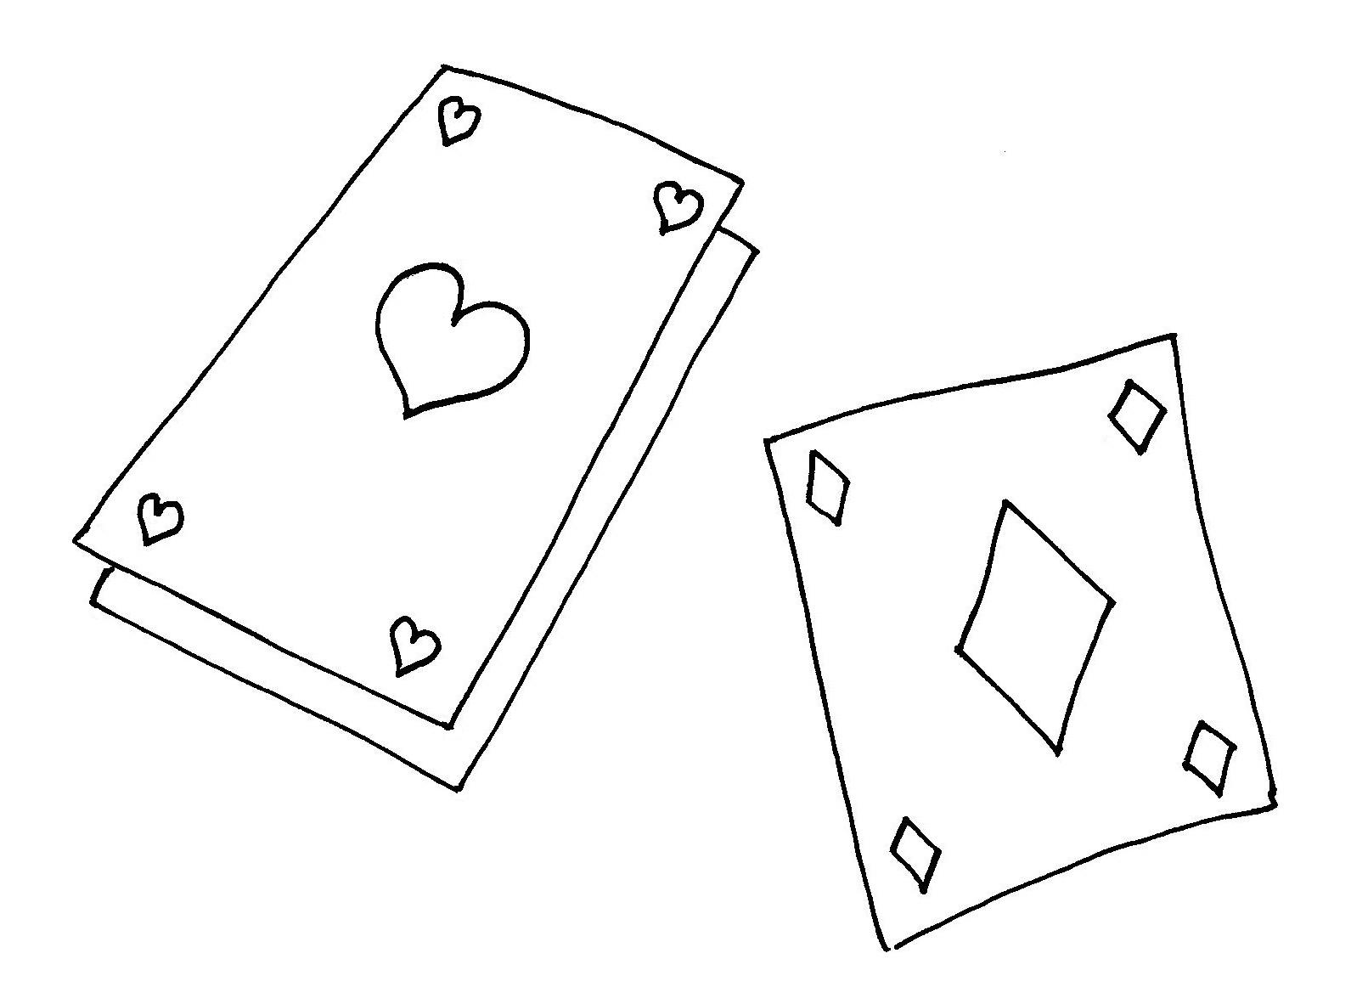
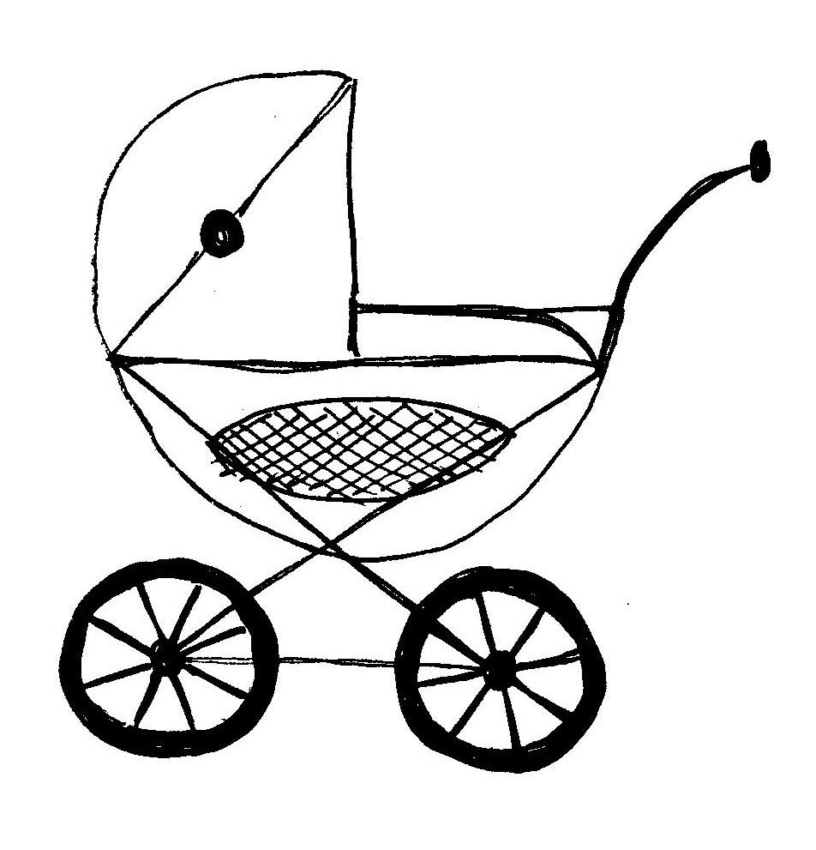

B
G
E
M
S
J
I
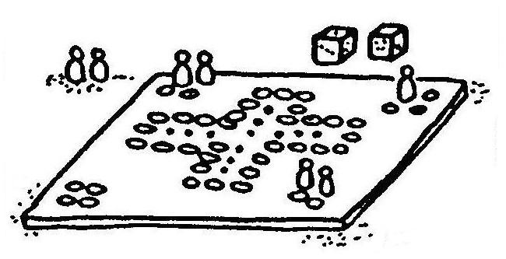
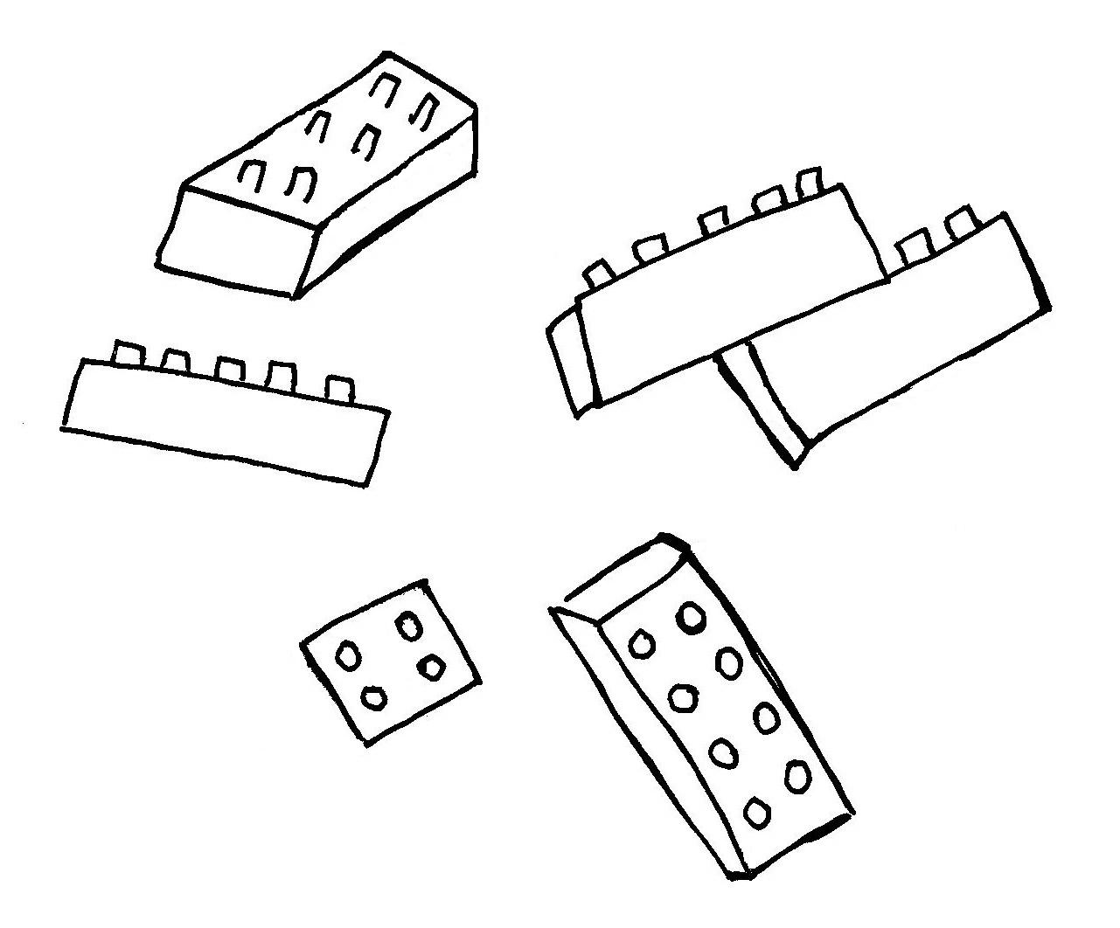
3. ročník
A
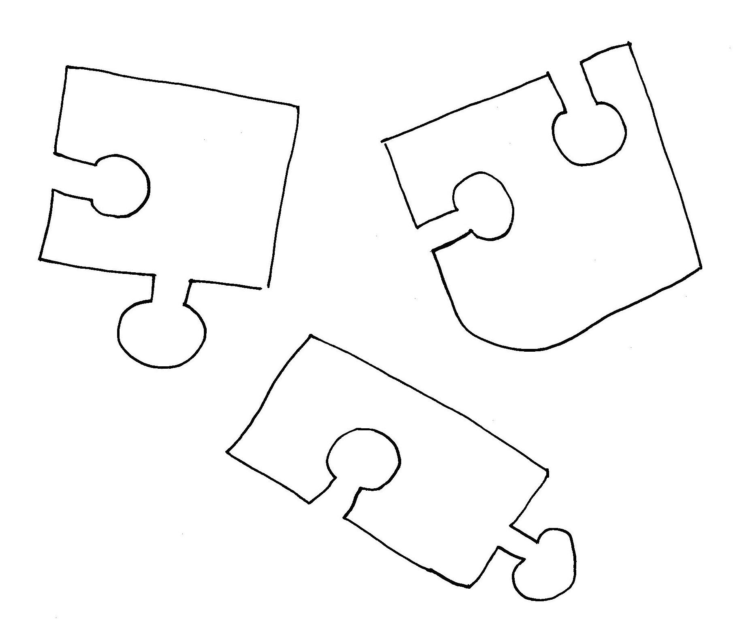
U
G
S

I
A
L
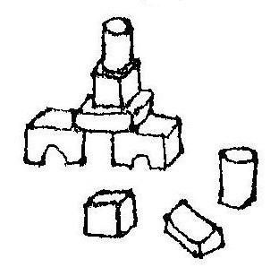
COMPUTER BUILDING SET
L
T
L
W
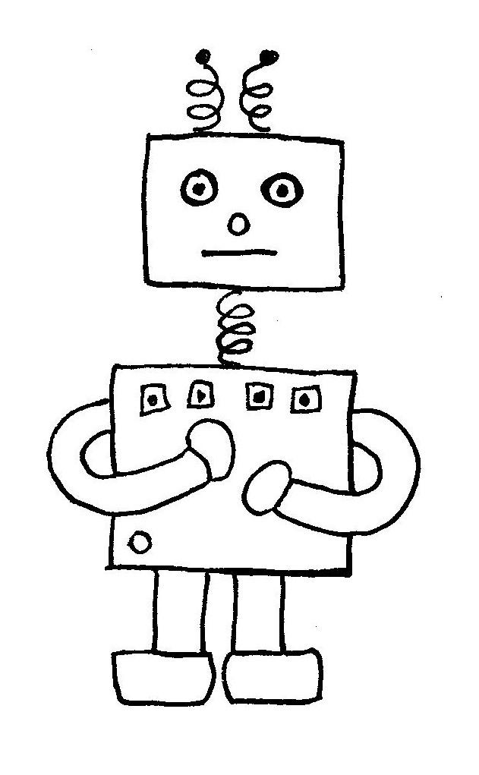
PRAM CARDS ROBOT
O
O
D
P
GAME DOLL BLOCKS
U
I
B
R
D
N
I
M
A
O
JIGSAW PUZZLE
Z
A
Z
R
O
G
A
K
E
S
E
R
E
L
B
H
D
S
H
C
A
A
L
P
T
E
R
S
T
E
P
U
M
W
C
B
L
KR
S
O
O
T
Y
C
O
B
PRA TER
H
U
CA PUZZLE
GA ME
COMPU RDS P__AM, BL__C__S, D__LL, R__BO__,
BLO CKS BU__LD__NG S__T, CO__PU__ER,
JIGSAW LL C__R__S, J__GS__W PU__Z__E, G__M__
BUILDING M
DO SET

LODL ________
MEGA _________
TMUROCEP ____________
SLOCBK _____________
DRCAS _____________
BROTO _____________
RAMP _________
DUNGBILI TES ______________
SAJGIW ZEZULP _____________

