Toys II
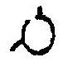
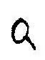
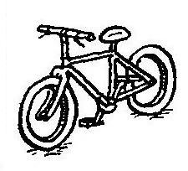
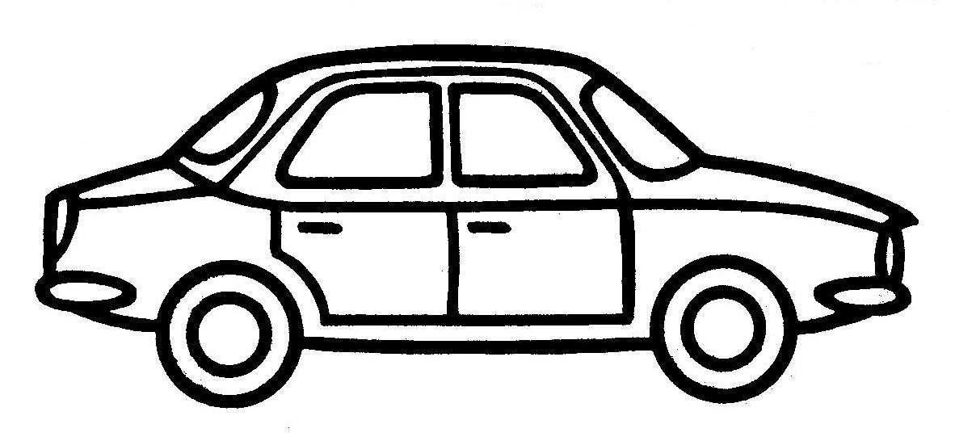
A
L
E
N
C
L
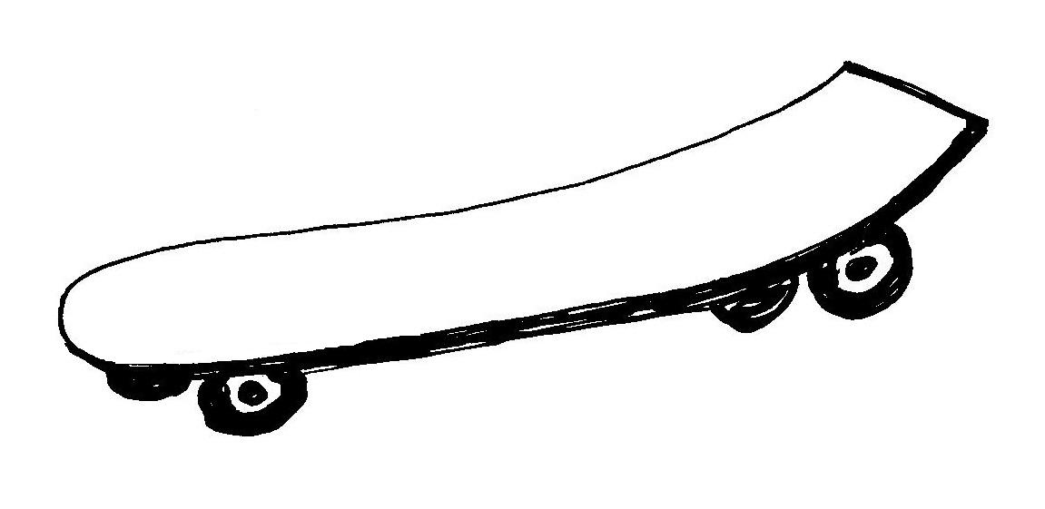
3. ročník
B
K
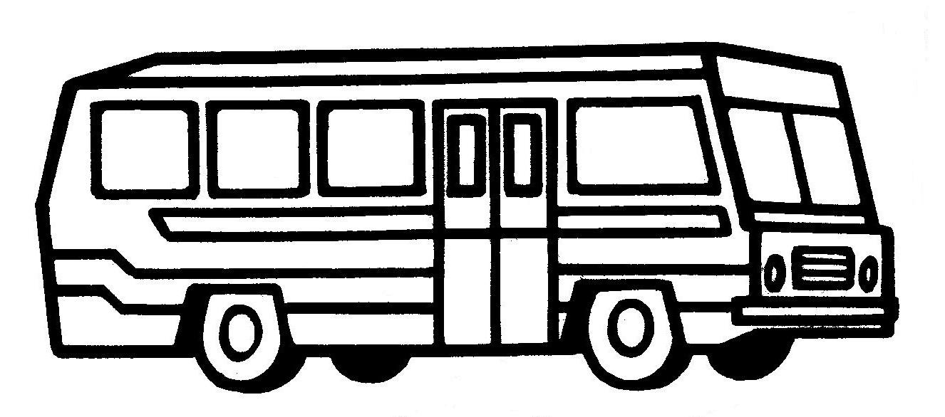
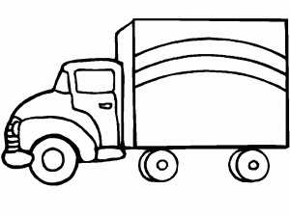
R
A
L
O
I
L
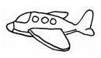
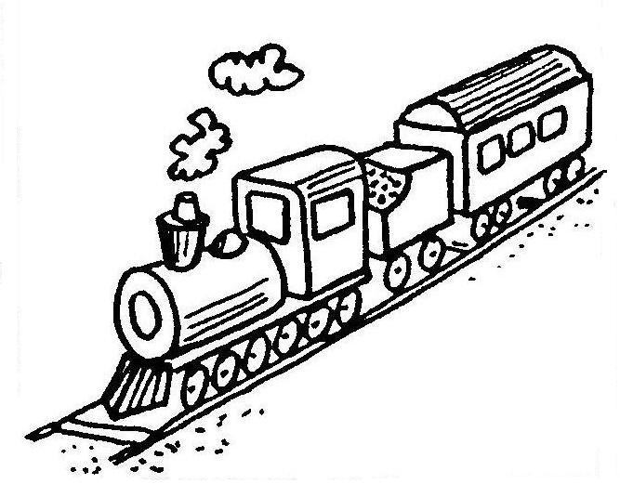
SCOOTER SKATEBOARD
L
B
O
P
CAR LORRY BIKE
L
D
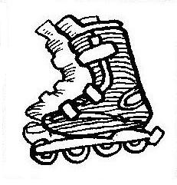
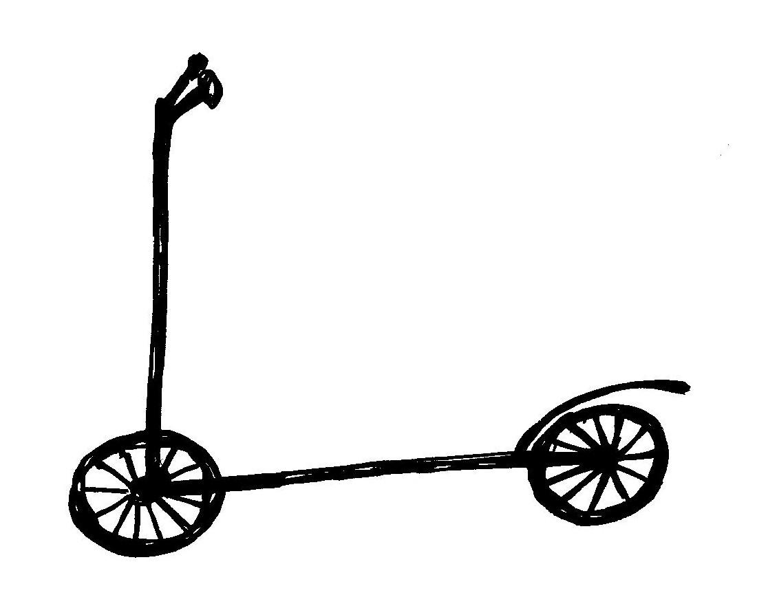
R
N
PLANE BUS TRAIN
E
I
R
R
Y
P
A
A
Y
ROLLER SKATES
S
A
R
S
O
B
R
H
K
E
U
E
T
L
L
B
T
S
H
S
K
A
Y
R
U
W
A
E
E
T
C
A
R
N
T
L
I
RR
O
S
A
T
Y
C
O
B
PLA TER
H
U
CA RY
BI NE
SCOO IN P__AN__, B__KE, __AR, S__OO__ER,
LOR SKATES RO__LE__ SK__T__S, L__RR__, B__S
ROLLER R T__AI__, S__AT__BO__RD
TRA KE

DOBRATESKA ________________
KEIB _________
STOROCE ____________
LEPAN _____________
LORLER TEKSAS ________________
TIRAN _____________
RYROL _____________

