Toys

3. ročník

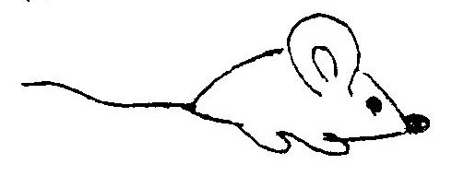
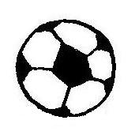
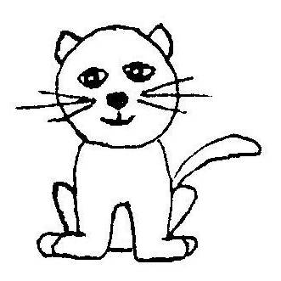
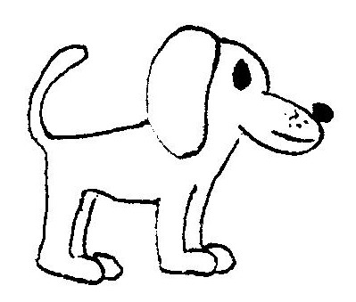
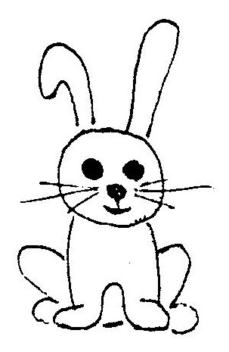
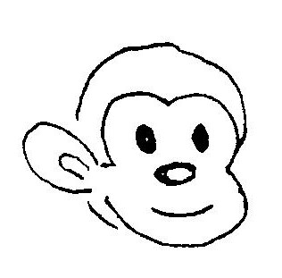
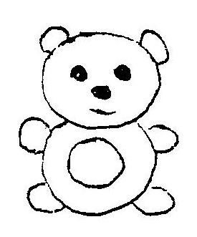
MONKEY
B
K
B
A
E
B
N
B
Y
G
D
O
Y
M
C
T
O
B
B
S
D
E
U
B
T
B
D
B
B
B
B
E
A
R
B
B
I
A
T
R
B
B
L
B
B
B
B
B
B
B
L
B
B
A

CAT RABBIT DOG

MOUSE BALL
TEDDY-BEAR

TED BIT
CA OG
B SE
MON ALL M__US__, D__G, __AT, R__BBI__,
D DY-BEAR TE__DY-BE__R, M__NKEY, B__L__
MOU T
RAB KEY

ACT _______
GDO _______
LALB ________
NYMEKO ____________
SUOME _____________
TIRBAB _____________
DYTE-DRABE _________________

